**Review of Fossilization**

Please answer questions 2 and 3 using complete and detailed sentences.

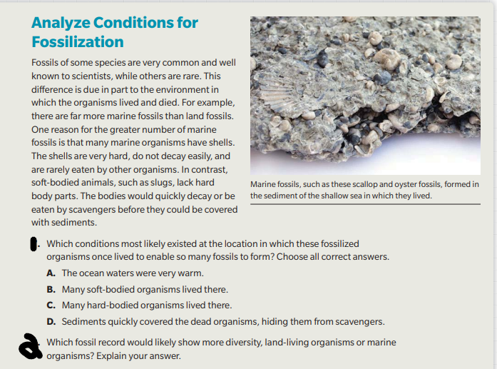

* **Answer to 1: C and D**

**Answer to 2: The Marine organisms would be more diverse because there are more marine fossils than land fossils which proves their greater existence than land fossils. Also the Marine organisms live in the ocean so they would be more durable and wouldn't decay as much as land organisms.**

**Question 3**

**What are the limitations of fossil evidence? In other words, why don't fossils tell us everything about past life on Earth?**

**Answer to 3:** The limitations of fossils are mainly there weren't enough organisms to create fossils back then and the conditions were different and only few were made but the bones and fossils give us an idea what life was like back then. Fossils don't tell us everything about past life, the only thing they really tell us is where life came from and how it was different back then. But fossils are limited because there are only a few of them and with that many fossils there is not that much evidence to tell us more about the past.